

Love God, Grow in Grace, Share with Others

**The 2020 Annual Report of**

**Woodside Presbyterian Church**

**January 31, 2021**



**WOODSIDE PRESBYTERIAN CHURCH**

**TREASURER’S REPORT**

For the Year Ending December 31, 2020

The following reports are included for the Annual Report for 2020 (*The statements provided should be considered preliminary until reviewed and approved during the annual financial review to be performed in 2021. As of this report, the Woodside reports income and expenses on a cash basis*):

**Statement of Financial Position**

As of December 31, 2020



**Statement of Income and Expenses – General Fund**

As of December 31, 2020

**Income** – In 2020, Woodside General Fund Income was $938,384.93 (98.1% of budget), representing a 6.42% decrease from 2019 income. Contributing factors for reduced overall giving for 2020 include Coronavirus (COVID-19) pandemic restrictions on church gatherings that started in March 2020 and remained in effect throughout the year that effected in-person giving. However, Woodside did see an increase in online giving in 2020.

**Expenses –** Total expenditures for 2020 were $823,636,88 (87.3% of budget), representing a 0.3% decrease from 2019 expenditures. The Woodside staff did an excellent job in managing expenses, and all came in under budget for the year. Contributing factors for underspending budget included the decision not to hire a replacement for the Director of Ministry who resigned during the first quarter of 2020, the timing of the hiring for the Director of Youth Discipleship and an organist, and COVID-19 restrictions on church gatherings which effected operational expenses. It is anticipated that salary expenses will be closer to budget in 2021, as all budgeted positions are anticipated to be in place for the full year. It is unknown as to the effects COVID-19 restrictions will have on Woodside in 2021.

**Net Income –** Woodside recorded net income of $114,748.05 for the year, down from $176,657.86 in 2019 (a decrease of 35.05%). This is a result of Woodside income being greater than its expenses, for reasons described above.

**Balance Sheet-** At the end of 2020, there was a $150,028 balance in current liabilities, and a long-term liability balance of $150,000, representing the Federal Paycheck Protection Program (PPP) loan taken by Woodside to compensate for both church and preschool salaries. Woodside has completed an application for loan forgiveness and is awaiting response.

On behalf of the Finance and Stewardship Teams, I would like to thank all of the teams for carefully managing their budgets during the year and the congregation for their faithful contributions, both monetary and through service.

**Respectfully submitted,**

***Brian Bozarth,*** Treasurer



**FINANCIAL CHARTS AND GRAPHS**

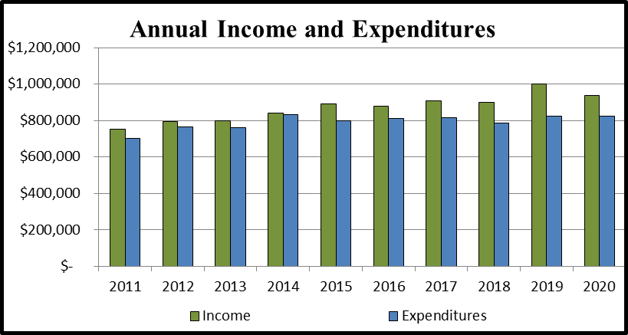

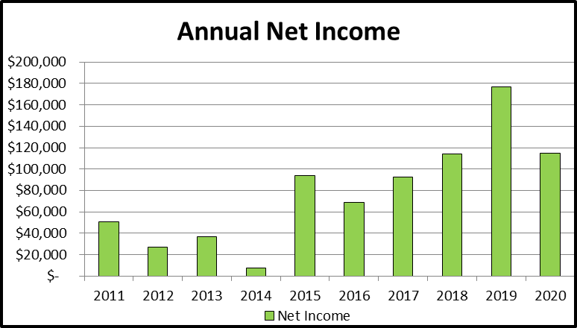



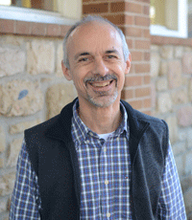**Doug Hoglund - Report of the Pastor**

The third month of 2020 will forever be a memorable milestone for our family. On March 8th our first granddaughter Evelyn Vera Kliefoth was baptized at Woodside. Ten days later our second granddaughter Eloise Jane Hoglund was born. Between those two joyful landmarks lies the beginning of another moment we will never forget – the shutdown caused by the Coronavirus. On March 15th Woodside left the building to gather and serve the Lord online only. At the time few predicted we would still be socially distanced and wearing masks into the New Year. None of us imagined Easter, Christmas and many Sundays shared only over the internet. It was a year filled with disease, distance and divisiveness. My heart especially grieves for those of you who lost a loved one due to Covid or other illnesses.

Yet Covid could not stop Jesus or you, Woodside. There were many advances in 2020 thanks to your faithfulness and the power of the Holy Spirit.

We said thank you to Michelle Thompkins for her faithful leadership as Director of Ministry. Though she stepped away from her staff position, Michelle still rallied us to an incredible coat drive for the Mill Hill community in Trenton and joined the Deacons, Reach Ministers and Hope for All Ministers in making Caring Calls to check in with and pray for our members.

After an extensive search, Woodside welcomed Joe Cain to be our new Director of Youth Discipleship. A passionate evangelist and compassionate youth leader, Joe brings experience, wisdom and deep faith to help our students become committed followers of Jesus. At the end of the year Woodside joyfully welcomed a new organist to the bench at the Classic Service: Sudeep Pakyanadhan.

Worship services went online first as recordings and then through livestream. Over the summer we enjoyed outdoor worship and, in the fall, returned to offering four services in person. Growth Groups continued meeting over zoom. Several Microchurches – gatherings of 4-6 people - popped up.

Our nation’s focus on racial justice offered Woodside the opportunity to hear the stories of our African American members, discuss the movie Just Mercy, study the book of Habakkuk, host a conference of diverse church leaders, and form groups designed to Overcome Prejudice Together. We also gathered to support and pray for the Stringer family in their advocacy for their daughter Kim and for compassionate care for neighbors burdened by mental illness.

Woodside stepped up missions by dedicating the Habitat house we framed in our parking lot, feeding 4,000+ Hungry Frontline Heroes, sponsoring monthly blood drives & food collections, contributing over $48,000 to Home for Christmas, and giving away $101,000 to mission beyond our walls.

After the shutdown in March I posted daily encouraging messages on Facebook, led a webinar after Easter called “Made for More,” filmed videos on Jesus’ Kingdom parables and coached the Parkland campus when Pastor Greg took a new church. I am extremely grateful for our wonderful staff and leaders who work, pray and seek the Lord’s will for Woodside during this rapidly changing pandemic. Please read their reports and see the incredible things they accomplished in 2020.

My prayer is we will emerge from this time stronger, deeper and more in love with Jesus. “May God himself, the God of peace, sanctify you through and through. May your whole spirit, soul and body be kept blameless at the coming of our Lord Jesus Christ. The one who calls you is faithful, and he will do it.” I Thessalonians 5:23-24.

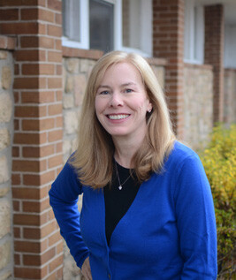 **Karen Clark Littley – Financial Administrator**

* I’m certainly not alone in joyfully saying goodbye to the year 2020! For Woodside’s finances, 2020’s world-wide pandemic brought much uncertainty. Thankfully, the Woodside community continued to generously support our missions and ministries through their financial gifts. It was often very quiet in the church office as the finance/bookkeeping team continued to do our work throughout the pandemic. I thank the volunteer Counters for their ongoing support preparing the deposits weekly, while maintaining “social distance.”
* **PPP Loan:**  In April, Session decided to proceed with an application for a potentially forgivable PPP Loan through the federal government’s CARES Act. In May, the church received approval of its request for $150,000 loan. Proceeds were used by the church and the preschool to support payroll expenses. In December the church applied for the PPP Loan forgiveness. We are awaiting feedback on the application.
* **Stewardship:** Giving to the 2020 General Fund totaled $911,915 (slightly higher than budget) from pledged and unpledged giving. Although there was no specific capital campaign in process during 2020, giving to the 2020 Building Fund totaled $10,587.
* **Finance**: When worship services went all on-line in March we saw a welcome increase in online giving. Online giving represented about 51% of General Fund giving in 2020 (up from 33% in 2019) and stock donations represented about 5% of General Fund giving (down from about 6% in 2019). We hope to continue to grow the percentage of online giving in 2021. Many of our regular givers opted to set-up recurring gifts either through the Vine with a bank ACH transaction or by credit card. Woodside appreciates the reliable nature of recurring gifts in uncertain times.

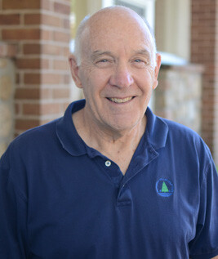 **Bruce Jones – Facilities Manager**

* **COVID-19 Pandemic Response** – March presented some significant hurdles to learn about, evaluate and take timely actions to assure an appropriate facility approach to providing a safe environment for church and school operations. With swirling information and panic buying options were often not clear and/or could not be managed due to supply chain issues. Decision as to a course of action utilizing principally hydrogen peroxide as the primary disinfectant yielded a three-tiered process to provide a safe facility environment. Two pieces of equipment were purchased for whole room and multiple room wide area disinfecting supplementing spot disinfecting of hard surfaces between uses. Gloves, masks, disinfecting wipes and chemicals were purchased from a wide variety of sources to include even out of the country. Unfortunately, most purchases into the fall were at premium prices. A modest inventory of supplies is now on site.
* **Office Remodeling** – Although it took about six months due to the pandemic, remodeling was accomplished in the south wing of the church offices and the older rest rooms. Investigation of the project found a lack of heat in this office area (from 1998) which required attention prior to starting the remodel project. Candis Mirande and Rich Carroll contributed their expertise.
* **Church Services** – Another spinoff from the pandemic was finding alternate ways to provide and/or produce church services. Fortunately, we had developed an On Demand video ministry which provided a starting point to move forward. The first pandemic driven service was on March 15 and we are still fine-tuning multiple ways to bring Woodside Church Services into people’s homes. Some equipment previously used to start up what is now the Higher Ground service was revived and utilized to provide outdoor services July into October. Live Streaming was added in the fall permitting viewers the option of using the church website, Facebook or YouTube. Live Streaming for the Classic and Higher Ground services as well as On Demand posting brings us into 2021. Many from the church came forward to make this ever-changing situation work.
* **Utilities** – The contracts signed in November 2019, provided some significant savings on the cost of gas and electricity over 2020. As of September, over $15,000 in actual savings was realized. Unfortunately, we have been working on a billing problem with PECO so a final projection can’t be made. The contracts will carry over into 2021. LED bulbs were installed in the Sanctuary, meeting room and west hallway. A bid was accepted to modify the fixtures in the school wing (east hallway) and will be done in January 2021.
* **School Wing Roof and HVAC** – A roof leak presented in the hallways and choir room attributed to a failing section of the roof that was poorly configured in the 1998 addition. Emergency repairs were performed and contracts issued to have the roof repaired and replace a (past end of life) 10-ton HVAC unit. Unfortunately, we have been hindered with supply chain issues obtaining all the necessary equipment to proceed due to numerous storms in the southern US over the year and businesses being closed due to the pandemic. This project will cost about $175,000.

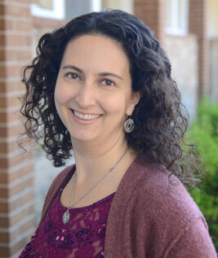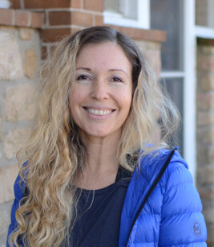

**Stephanie Hermesmeyer**

**Chantell Socha**

**Directors of Child Discipleship**

* Due to the Covid-19 pandemic, our programs (Discovery Kingdom, The School of the Rock, Adventure Club, Vacation Bible School, Push the Rock, and Savior Drama) took on a different form in 2020.
* During the first half of the year, we offered two Children’s Ministries Zoom meetings per week: one on Wednesday afternoons and the second on Sunday mornings. During our Zoom meetings, the children received a Bible lesson followed by discussion time. We would then work together on a craft or STEM project related to the Bible lesson. We concluded our meetings with prayer time. Despite the Zoom-fatigue from being at virtual school all the day, the children were very engaged with the lessons and enjoyed seeing their friends again.
* Over the summer, we all had a blast with Backyard VBS! Our theme this year was “Game On!”. Families picked up VBS bags with all the materials needed to hold a VBS in their backyards, either as a family unit or with neighbors and friends (with all Covid precautions in place). The kids chose team names and earned points for their team throughout the week by doing the daily activities. Each day, our families watched a homemade pre-recorded video lesson (recorded by a few of our families), practiced our VBS anthem, performed skits, played games, and did a craft. We had a private Facebook page where everyone could post photos of their day and the number of points they earned that day! It was a great way for the kids to see their friends and see everyone having fun. At the end of the week all the points went into a bag and we had a drawing for a visit from the water ice truck! It was a really fun week for everyone!
* In the Fall we started our new Children’s Ministry offering: Faithful Families. Faith grows at home and we want to empower families to learn about Jesus and grow in faith together. Based on our Foundations 4 Faith, each week we offer four opportunities for families to come together to reflect and discuss the lesson of the week: Faith-filled Sundays (kid-friendly Bible lesson based on that morning’s sermon with video(s) and discussion questions), Fellowship Wednesday (a time to get together outside at Woodside’s parking lot for family activities), Mealtime (prayer and discussion time), and Bedtime (prayer and discussion time). This program continues to grow and we are excited for where the Holy Spirit will lead us in 2021!

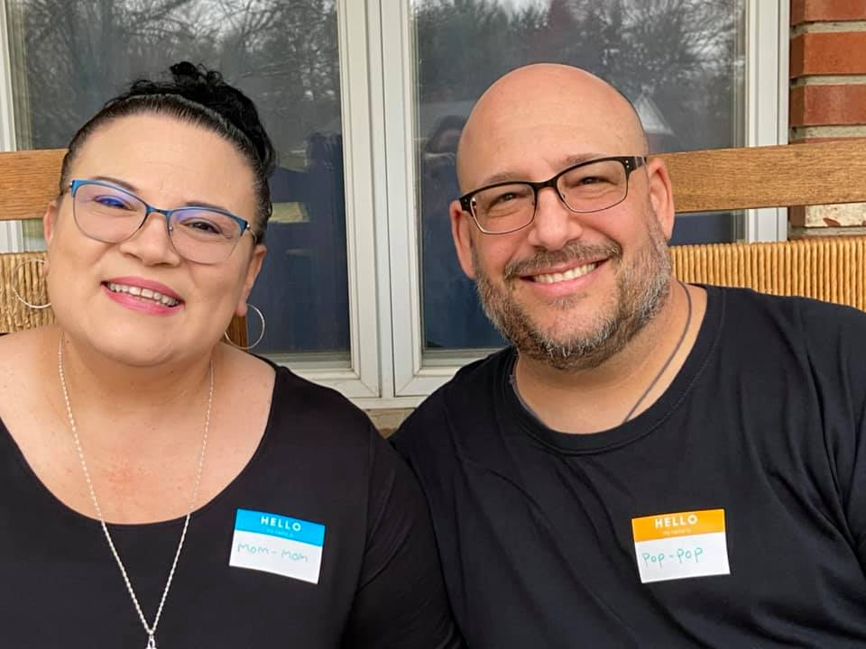 **Joseph Cain – Director of Youth Discipleship**

* **FUSiON:** Junior High is combined with 5th-8th grades. When we started meeting again, we had 3 students attending. We have grown to 13. Junior High is in a growing stage. Missions were with Operation Christmas Child and Families Feeding Families.
* *iGNITE:* Senior High - The student leadership is established and meeting. All small groups are facilitated by students with adult support and guidance.The Families Feeding Families was a huge success. We exceeded our goal of 50 boxes of Thanksgiving Meals. 20 families that attend Lower Bucks YMCA received a box. We partnered with Newtown Presbyterian Church to help with distributing the rest of the boxes that went to Trenton to feed low-income and inner-city families. They also have participated with Operation Christmas Child and Faithful Families Trunk-R-Treat. Currently 37 to 45 students attend and 9 adult leaders.
* Student Ministry Events: The Fall concert with Dave Pettigrew had over 80 people attend and Dave has agreed to grant us the opportunity to launch his spring tour in 2021.

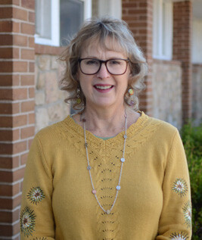**Martha Stringer**

**Director of Communications**

**Donna DeMaria - Administrator**

* In March we launched a new website.
* When the shutdown happened, we shifted our communication efforts to mostly online.
* We send 2 e-blasts a week with information about ways we can serve, general information about our ministries and connecting people back to our website, etc.
* Currently we post 4x per week to Facebook [(please be sure to "like" our page!](https://www.facebook.com/Woodside-Church-114921278546298)) as well as [Twitter](https://twitter.com/WdsideChurch) and [Instagram](https://www.instagram.com/woodsidechurchpa/?hl=en). We also send regular push notifications through the App.
* We continue to promote our App and promote the online Connection Cards and bulletin. When we are in the building, we offer paper options for those that prefer it but continue to encourage using the online option.
* We create videos for the announcements, promotions as well as teachings by Pastor Doug (as we did for Kingdom Come) and bumper videos for all our sermon series.
* In December we signed a contract with a new App service provider called Pushpay and have begun the implementation process.

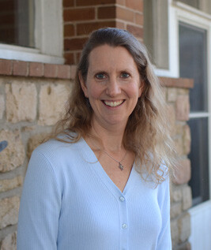**Dawn Wills - Director of Celebration Worship**

* This certainly has been a different year for worship at Woodside!  With the global COVID-19 pandemic affecting our ability to gather, our team has been challenged to develop creative ways to bring worship services to the Woodside community including:
  + Worship videos recorded in the Vineyard and at home
  + Outdoor worship services in the Woodside parking lot
  + Live streaming worship services (with or without a congregation)
  + Prerecorded Easter and Christmas Eve services available in Celebration, Higher Ground, Children’s and Classic styles.
* In order to facilitate these new worship modes, new technology was installed and our Celebration and Higher Ground tech teams have quickly expanded their recording and production skills.  By the end of this month all services should be live streaming regularly every week.  Many thanks to the team members who have invested so much time in learning and improving the quality of our video services so that people can participate in worship from the safety of their homes.
* Worship continues to be a priority for the senior high ministry, and when we meet in person, it is the Higher Ground band who provides this music.  We welcomed 6 freshmen members onto the team this year and I am excited to see this ministry grow in the coming years!
* While leading people in making music is a large part of my job description, worship is more accurately described as honoring God with every aspect of our lives--anytime, anywhere. Whether or not the building is open, it is my prayer that in every season we as a community of faith would live to glorify Him and inspire others to worship as well.

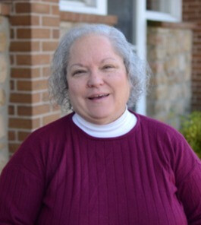

**Jane Read – Director of Classic Worship**

* 2020 is a year we won't soon forget, but with God's grace and guidance, Woodside found a way to worship Him with joy and thanksgiving.
* We started just after the first quarantine was declared with our Holy Week services. We were able to offer Maundy Thursday over zoom and record the Good Friday readings, hymns and songs that we love, as we remembered Jesus' sacrifice for us on the cross. For Easter we were able to record a Classic service by recording the organ and instruments in the sanctuary and adding voices and the rest of the service in the Vineyard.
* The Classic team shared worship with the Celebration team throughout the spring and summer, as we especially enjoyed our parking lot services. We returned to smaller inside in person worship in the fall, but suspended that in December.
* The team was especially pleased to be able to record our Classic Christmas Eve service in the Sanctuary with the help of our wonderful tech team. We were able to include bells, brass and choir who haven't been able to worship together since March. I am grateful to everyone who helped to bring this service together.
* Finally, we have welcomed Sudeep Pakyanadhan as our new organist and look forward to offering our musical worship together.

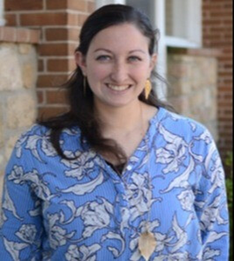

**Meg Smith – Director of Discipleship**

* In 2020 we had 53 Growth Groups, MicroGroups, & other new ministries, which included 7 coaches, 61 leaders, and 391 participants DESPITE the pandemic! God is moving! Some of the newer ministry groups included a Career Networking Group, Overcoming Prejudice Together (a discussion group that was so large, formed 2 groups), and a Racial Education Book Club.
* In the summer of 2020, we launched Woodside’s College Ministry. It started small with 4 Growth Groups, 17 participants, and 5 leaders. Dave Henry serves as the College Ministry Coach while Elizabeth Mele, Ben Vouk, Kerry Phillips, and Trinity Cain all served as leaders/planners for the start of this ministry. Many college-aged adults spoke with me throughout the summer to dream/plan for this ministry and gave me some great input! I’m looking forward to this ministry’s growth in 2021!
* I did many webinars in 2020 in order to continue to improve Discipleship at Woodside. I had many conversations with Doug to go over some of the information I gathered from the webinars and how we can implement some of those things into our church. Doug and I continue to look towards the future and build on what we have established already; including trying to maximize the role of coaches within Growth Groups, adding MicroChurches to our ministry, and trying to put together a more effective training model for Growth Group and MicroChurch leaders to go through so we can begin utilizing it in 2021!
* Woodside Women’s Ministry in 2020 could not go to Refreshing Mountain for their annual spring retreat; so they instead held a 4-Week Virtual Retreat on Zoom. They had between 20-40 women attend, the number varying each week. They are looking forward to a few in-person options to do in 2021 since gathering together in 2020 was desperately missed!
* Woodside Preschool families and teachers continue to receive a monthly recommendation for a RightNow Media program to use in order to spend quality time with each other and to utilize this wonderful tool that we offer to all at Woodside!

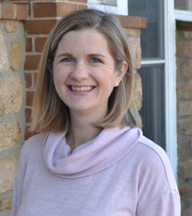

**Karen Savage &Tom Fowler**

**Directors of Fellowship & Hospitality**

* Woodside was the host site for Code Blue in January 2020. Meals and shelter were provided for those who needed it during the cold winter nights.
* Our first and last event of 2020 was the Ash Wednesday soup dinner held on February 26, 2020. We served 225 people. Due to COVID-19 there were no other special events held.
* The Hospitality ministry worked with the Mission Ministry to serve over 4,279 lunches to first responders and frontline workers in the Spring and continued to prepare meals for the dinner ministry on the second Monday of each month and for Cast Your Cares.
* Outdoor services in the summer were a wonderful way for us to gather together again safely. Members of the Welcome Team assisted with parking, greeting, and setup/cleanup.
* Indoor services resumed temporarily in the fall and several people from the Welcome Team volunteered to greet, assist with sanitizing the Vineyard after each service and help ensure safety protocols were follows to ensure everyone’s safety.

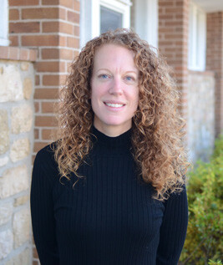

**Susan Harris-Miller Director of Mission & Evangelism**

* **MLK Day of Service:** Volunteers & Adventure Club wrapped 2000 utensils for TASK, made 166 cards for cancer patients, and decorated 237 placemats for Code Blue & Dinner Ministry guests.
* **Meals:** Many volunteers and the Children’s Ministry collected and donated a full meal and a $25 Shop Rite gift card for 64 families of Urban Promise in Trenton for Easter. Volunteers donated and filled gallon baggies with non-perishable food for TASK for children to have meals while not in school. The normal once a month Dinner Ministry (AHTN) to serve the homeless was expanded to twice a month. In addition, Woodside provided a to-go meal with a bagged lunch for the next day from April through September and Woodside families made 30 bagged lunches for the homeless every Friday in July and August. Feeding Hungry Heroes provided 4,279 lunches for essential workers from April through August. Food Panty collections were delivered throughout the year to Penndel Food Pantry and Interfaith Food Alliance-Morrisville.
* **Housing:** Woodside was open for Code Blue 16 nights in January with an average of 24 guests per night for a total of 384 guests over the 16 nights, 29 of which were new. Woodside hosted one homeless family for Family Promise during the months of July and August.
* **American Red Cross:** Woodside sponsored 6 blood drives in 2020 where 251 units of blood products were collected that could help save 753 lives.
* **Christmas missions** – Woodside was a collection site for Toys for Tots this year with many new toys being donated. 188 new children’s coats (44 more than requested!) were donated and delivered to under privileged children at the Millhill Development Center in Trenton. The annual Angel Tree project brought in 141 toys or gift cards for children whose parents are in recovery from drug and alcohol addiction through the Council of Southeast PA, Inc, Recovery Support Services.

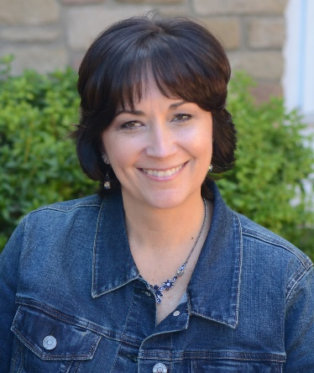

**Sherri Wolf – Director Woodside Christian Preschool**

* Woodside Christian Preschool is proudly operating for our 32nd year of serving families and children. After having a mandatory closure in March of 2020, we finished our 2019-2020 school year with some virtual options for classes and a drive-by "Moving On" program in May. In the midst of a global pandemic, we were able to open our doors in October - offering a total of 7 classes and have 80 students enrolled for the 2019-20 year. Each class is capped at 12, so this is a sizeable difference from years past. We are only 4 students short of being at maximum capacity. We also have a new payment method that began this year! Families are now able to sign-up for ACH bank drafts through Woodside Church. We will continue to use this payment method in the years to come.
* Our staffing has seen significant changes for 2019-20. With the local school closures and Covid19 concerns, we had 12 staff members who were NOT returning to join us for this year - that was about half of our staff! I am thankful to report, that we were able to adequately staff each room with qualified teachers. We have 2 teachers in each room this year and since we are not offering our specials, our staff needs did decrease. The wonderful individuals who joined our team this year are Sue Harris-Miller, Chantell Socha, Lori Stevens, Kim Palmieri, and Rebecca Tarallo as part of our regular staff. We also added Julie Goldberg and Linda Brayshaw to our substitute staff team.
* I spent most of the summer working full-time to adjust our schedules, staffing, and procedures to meet the roller-coaster ride of changes. I held 3 staff meetings regarding COVID-19 discussions and protocols to be in place for our opening. I met weekly in zoom meetings this summer with other faith-based directors in preparation to reopen and developed our "reopening plan" to be available online for our families and the community.
* Two significant adjustments we have had to make are how students enter the building and how we connect with families. We now do a drive-by drop-off and pick-up procedure for every class. This new method means that parents (or caregivers) are not able to personally interact with teachers at the door. To assist with whole school communication and help foster class to parent connections, we purchased a subscription to a communication platform called BLOOMZ. The Bloomz app allows teachers to take photos of their day and send them to parents. We also use it to sign-up for conferences, donations to class, and everything related to our school announcements.
* Finally, although we are not able to offer our weekly specials (music, Jump4Joy, and Exploration Station), we've made adjustments and held a costume parade in the Vineyard, and sent videos to parents. We had a simplified "Happy Birthday Jesus" party for each class, and we hold our monthly religious lesson via video streaming of Pastor Doug (he is now a video star!). Our staff has been super flexible and willing to adjust in so many ways. We've been Covid FREE and praise God for each day we have at WCP!!!

**Elder Michele Cayemitte – Nominating Team**

* The 2020 Nominating Team was chaired by Elder Michele Cayemitte and Elder in Training William Romig representing the Session, Anthony Mannarino representing the Deacons, and the Rev. Dr. Douglas Hoglund (ex officio). Members representing the congregation were Erin Baker, Richard Law, Meg Pieslak, and David Outcalt.
* Members recruited and nominated for positions in the Class of 2023 are Elders Victor Cole, Gbenga Oladeji, and Jamilla Stafford. Deacons in the Class of 2023 are Jacqueline Cole, Albert Einwechter, Nancy Einwechter, and John Hughes.
* The 2021 Nominating Team will be chaired by Elder William Romig and Elder in training Wade Jacobson. The Deacon representative will be John Hughes.
* Members representing the congregation at large to be placed in nomination before the Congregation are: Peter Clark, Jeffrey Hill, Cyndy Montes, and Laura Ruland.

**David Clift – Moderator of the Board of Deacons**

* As of September, the Deacons participated in the Caring Call Team with REACH ministers and Hope for All Care Givers to call each Woodside member and regular guest household to touch base with them, ask if they needed any help, and what they would like prayer for. This outreach had been started in March by Donna DeMaria through the church office. Great feedback was received as well as updated information and lots of positive responses from these calls. Needs that came from these calls were addressed.
* The Deacons assisted with one funeral in the church in 2020.
* There was one Red Cross blood drive in February that the Deacons assisted with prior to the Red Cross taking over the handling of all subsequent blood drives at Woodside in 2020 because of Covid-19 precautions that were in place.
* There were 3 home communions administered by the Deacons before Covid19 restrictions were put in place.
* Devotional books were given to graduating high school seniors.

**Clerk of Session**

Total Active Membership as of January 1, 2020……………………… 783

Losses: Transferred members………. 1

Deaths…………………….... 8

Removals*.………………... 0

**Total Losses**……………………………………. 9

Gains: Transfers to Woodside……...... 0 Profession of Faith…………… 0 Reaffirmation of Faith……….. 0

Confirmation……………….... 9

**Total Gains**…………………………………… 9

**Net Gain** (Loss)…………………………………. 0

**Total Active Membership** as of December 31, 2020…………………... 783

*Removals from the Active Roll were active members who requested their removal or moved away without requesting a transfer of membership and members who had been inactive for more than 2 years.

Ten-Year History of Communicant Membership at Woodside

|  |  |  |  |  |  |  |  |  |  |  |  |
| --- | --- | --- | --- | --- | --- | --- | --- | --- | --- | --- | --- |
| Year | **2011** | **2012** | **2013** | **2014** | **2015** | **2016** | **2016** | **2017** | **2018** | **2019** | **2020** |
| Gains | 57 | 52 | 67 | 55 | 62 | 49 | 49 | 49 | 45 | 54 | 9 |
| Losses | 27 | 17 | 41 | 61 | 26 | 28 | 28 | 46 | 39 | 29 | 9 |
| Net | 30 | 35 | 26 | -6 | 36 | 21 | 21 | 3 | 6 | 25 | 0 |
| Total | 638 | 673 | 699 | 692 | 728 | 749 | 749 | 752 | 758 | 783 | 783 |

Six-Year History of Worship Attendance at Woodside

|  |  |  |  |  |  |  |
| --- | --- | --- | --- | --- | --- | --- |
| Year | **2015** | **2016** | **2017** | **2018** | **2019** | **2020** |
| Average attendance each Sunday | 425 | 425 | 374 | 338 | 346 | 207* |
| Average attendance per Sunday as a % of membership | 58% | 57% | 50% | 45% | 44% | 26% |

**\***This number is a combination of 4 services held each of 10 Sundays in the church building in January through mid-March 2020, 1 outdoor service held on 12 Sundays in the parking lot, and 9 limited capacity in person services n the fall of 2020. 60% of the services were in person while on all other Sundays the building was closed and services were only available online on demand or live streamed.

**Baptisms**

Name Date of Birth Date of Baptism

Natalie Mary Badilla January 11, 2004 February 2, 2020

William Yates Livingston October 7, 2004 February 2, 2020

Charlotte Alexa Canning June 5, 2015 March 1, 2020

Nicholas Bryson Oberto April 27, 2006 March 1, 2020

Evelyn Vera Kliefoth November 3, 2019 March 8 2020

**Marriages**

Names Date of Wedding

Michael J. Reynolds Sr. and Donna Lynne Kimball September 3, 2020

William Henry Taylor V and Autumn Hunter Whitecraft October 17, 2020

Douglas Todd Murray and Urna Chakraborty November 6, 2020

Ryan Joseph Lieb* and Rebecca Ann Hoefler November 14, 2020

**Deaths**

Name Date of Death Date of Service

Ingeborg K. Giles Richards February 28, 2020 March 5, 2020

Joanne E. Brecht March 3, 2020 March 21, 2020

Cathy Jo Burries Mack* April 9, 2020 April 21, 2020

Charles Thomas Hovemeyer* April 13, 2020 Private

Dustin Ray Martinez March 24, 2020 June 6, 2020

Barbara Elizabeth Camp* June 19, 2020 June 26, 2020

Susan Bannon July 4, 2020 July 9, 2020

Michael Dardes* September 18, 2020 September 29. 2020

Ruth E. Coyne* October 4, 2020 October 8, 2020

Frederick T. Seman October 12, 2020 October 17, 2020

Gloria Fitzpatrick* November 19, 2020 to be held in 2021

Patricia Hilliard* December 15, 2020 to be held in 2021

Ruth Osmond Wright* December 26, 2020 to be held in 2021

*indicates member on Active Rolls of Woodside

